Muhammad Muntazer Mehdi

**Configure the topology**

**using CLI mode**

**Task 1:**

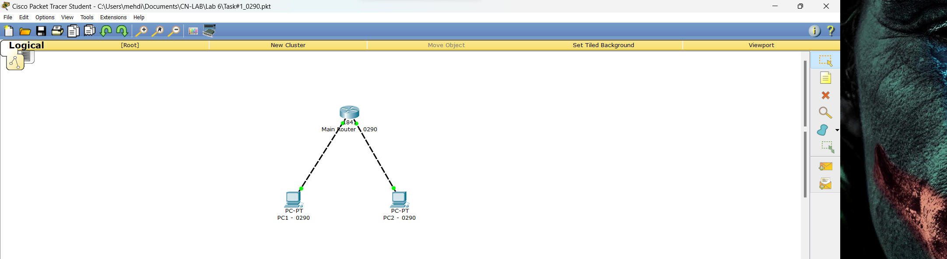

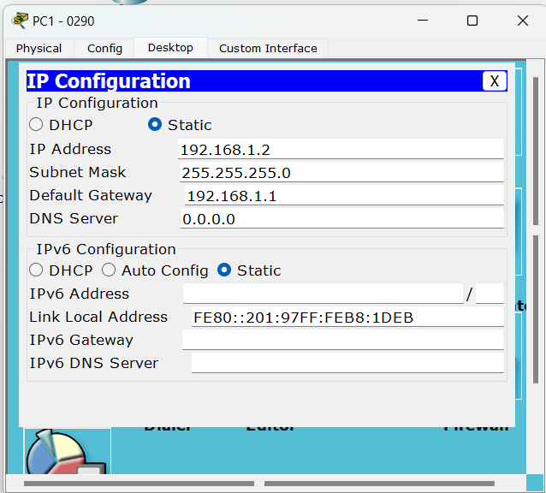



**Task 2:**



